2015 Summer Reading and Writing Bingo

Read a book about an animal. What is your favorite animal and why? Is it narrative or expository? | Put yourself in the setting of a book, write and illustrate a postcard. Mail it to the Reading Room or drop it off.  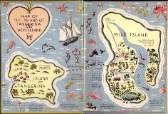 | Read a book with a pet or a stuffed animal. | Watch a movie about a book and write an opinion review. Which did you like better and why? | Take a walk with a friend or family member and discuss your favorite book or author.
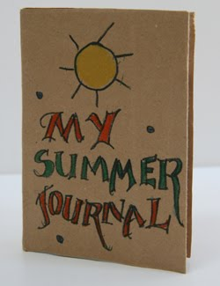  Keep a summer journal of all your adventures! | Read a book with a one word title.  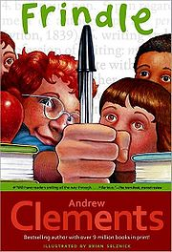 | Find a list of sports teams in the newspaper or online. Locate them on a map and put them in ABC order. | Read a fable, fairy tale, myth or folktale. Was there a lesson to be learned? | Read an article from a newspaper. Now you are the reporter, write a sizzling narrative  summer story.
Have a book share at the dinner table at home or at camp one night.  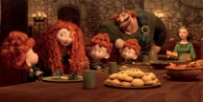 | Practice your handwriting or cursive with sidewalk chalk. | Sign up for the Hingham Public Library Summer Reading Program. | 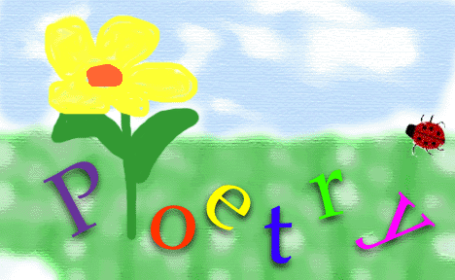  Read a book that rhymes or a book about poetry. Write your own poem/rhyme. | Read a book under the stars with a flashlight.
Visit a museum or another place of interest. Tell a relative or friend something new you learned. | What is your favorite series? Is there a new book?  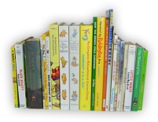 | 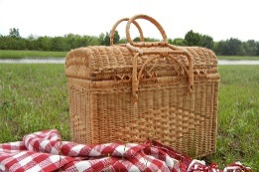  Have a reading picnic at the park or the beach – bring a book to read after you eat. | Make a craft or recipe from a book. What math skills did you use? | Read a book from your favorite genre (mystery, fiction, biography, etc).  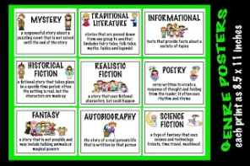
Go for a walk outside and make a picture. What senses did you use? | Swap a favorite book with a friend. Why did you pick your book?  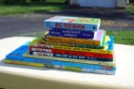 | Go on a scavenger hunt in the library. Find books on the same subject. Did the author write the book to entertain or inform? | Cut out pictures from an old magazine or catalogue and write a story using them. | Read a joke book. Learn one and tell it to a friend.  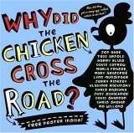
Have fun reading and writing this summer! Earn a BINGO by completing five squares in a row – up, down, across, or diagonally! Go to Hingham Public Schools, click summer assignments to get more great ideas.

